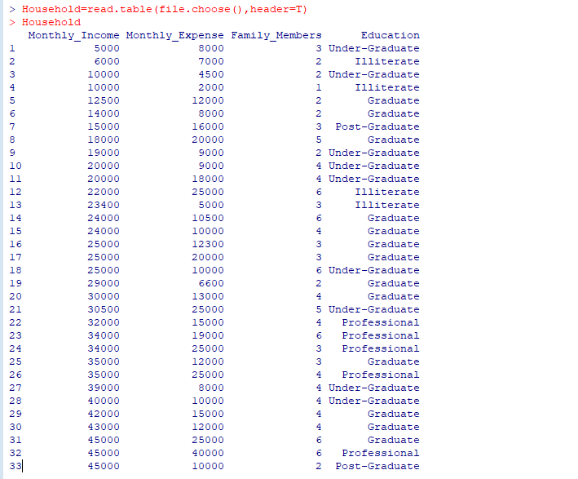

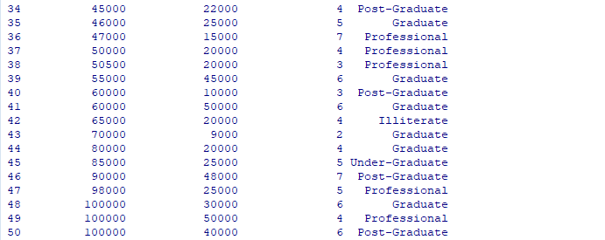

1. 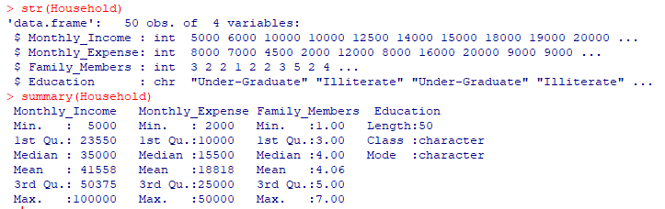
2. 
3. 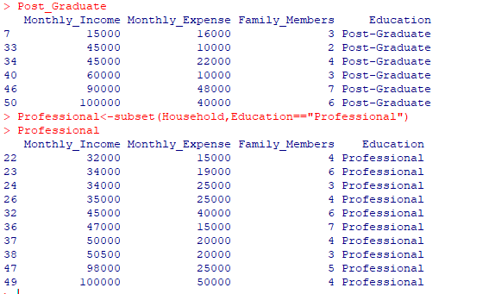
4. pie(table(Education))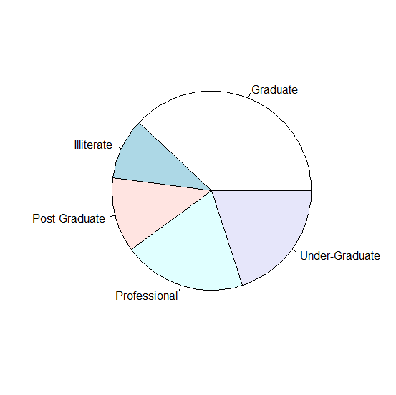
5. boxplot(Monthly_Income~Education)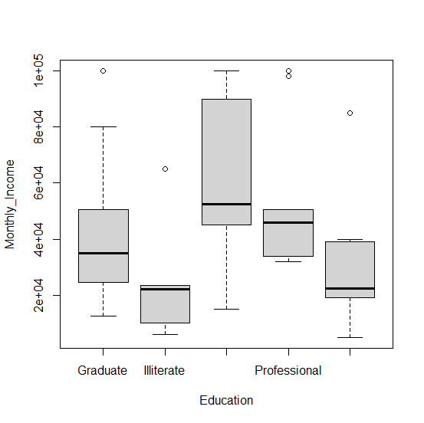

Families with the post graduate education have the highest monthly income while the illiterate families have the less. Other education levels have medium income compared to the others.

1. plot(Monthly_Income,Monthly_Expense)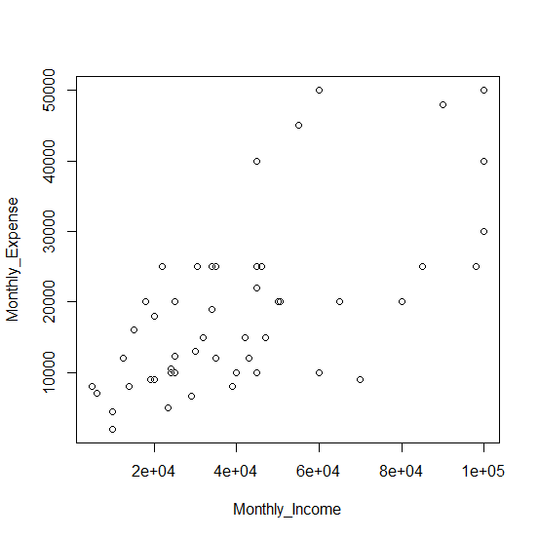

Monthly income and expenses are positively correlated; as income rises, expenses tend to increase.

1. hist(Monthly_Expense)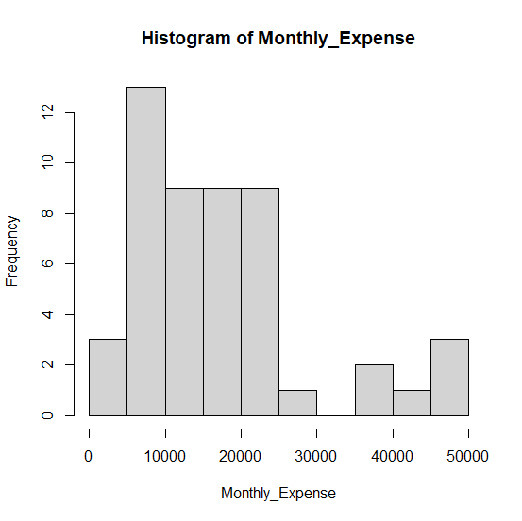

Histogram indicates that the majority of individuals have monthly expenses between 5000 and 25000 with the most common range being 5000 to 10000.

Positively skew